Docker Task 3
Task Description:

Create a custom docker image for nginx and deploy it using docker compose, where the volume bind mount should be at /var/opt/nginx location. Push the created custom docker image to your docker-hub.
Techstacks needs to be used :
AWS EC2
Docker
Docker Compose
AWS EC2 Creation:
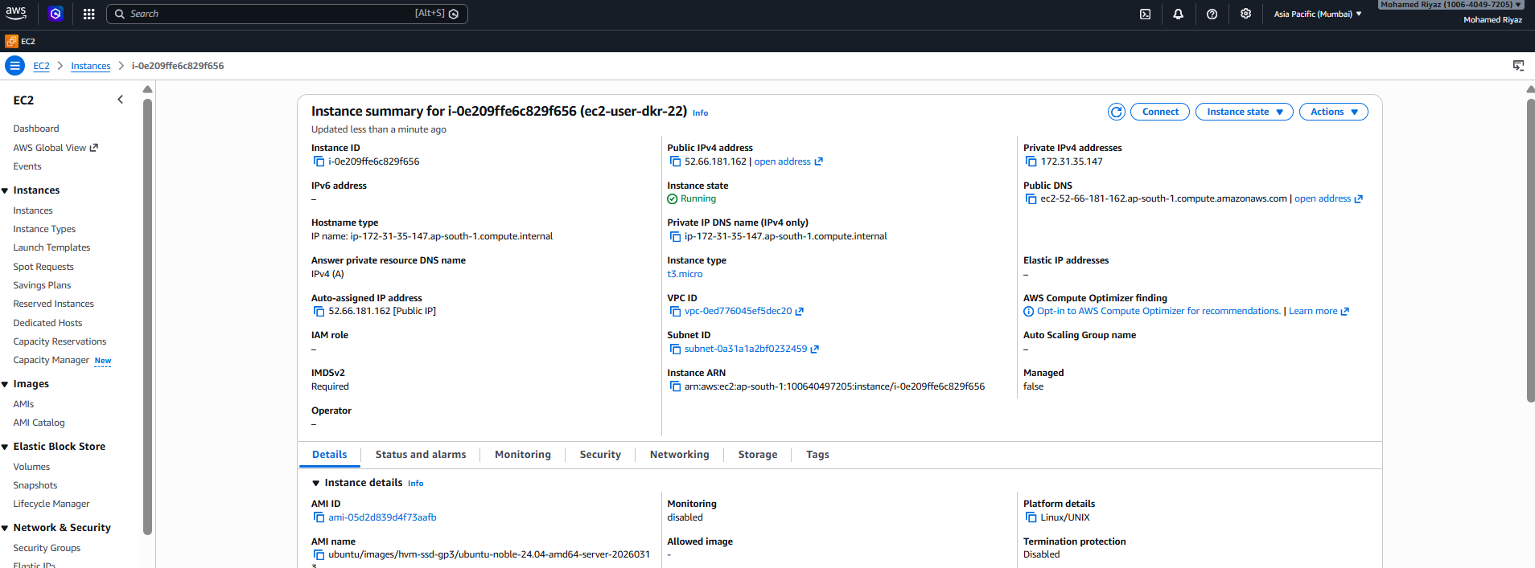

Putty:
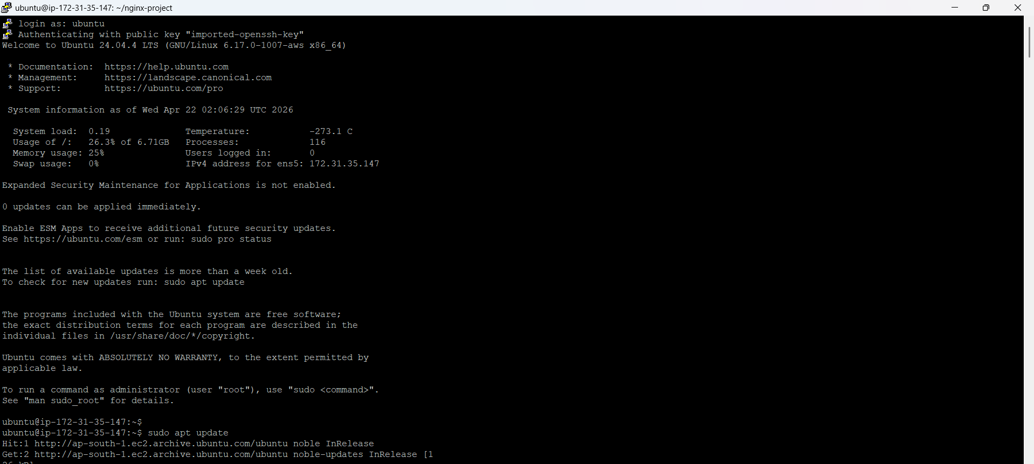
Docker Install:
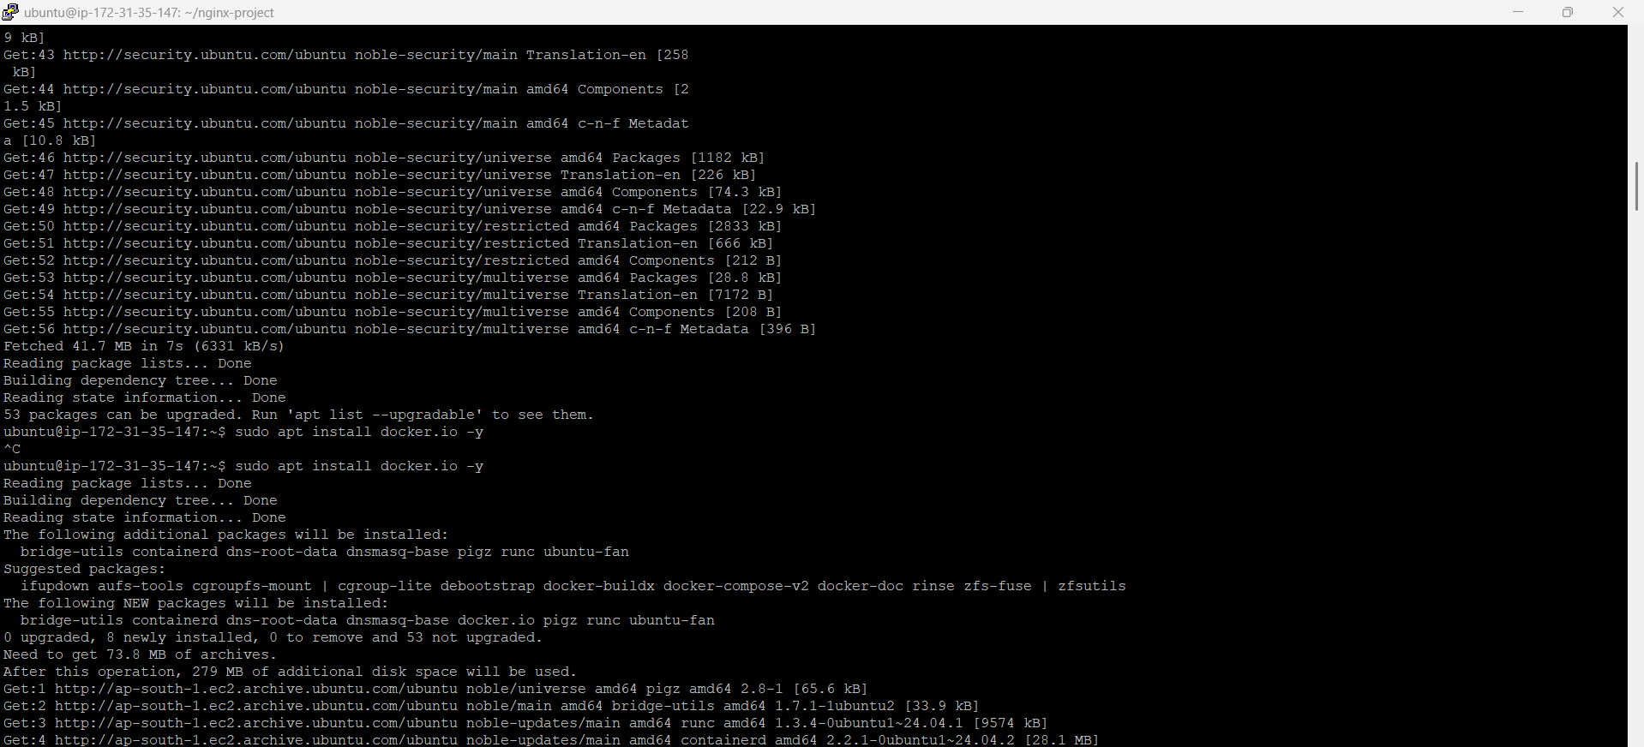
Docker Compose:
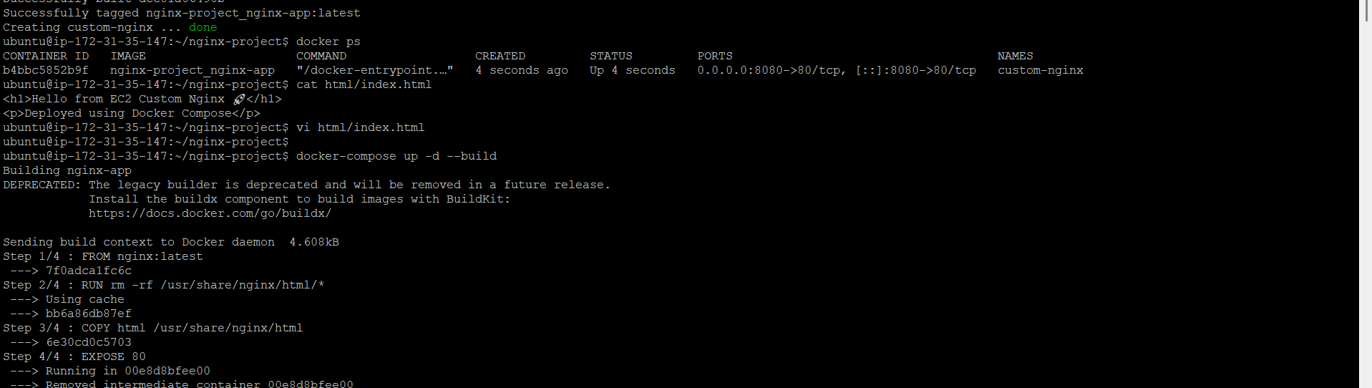
Push Image into Hub:
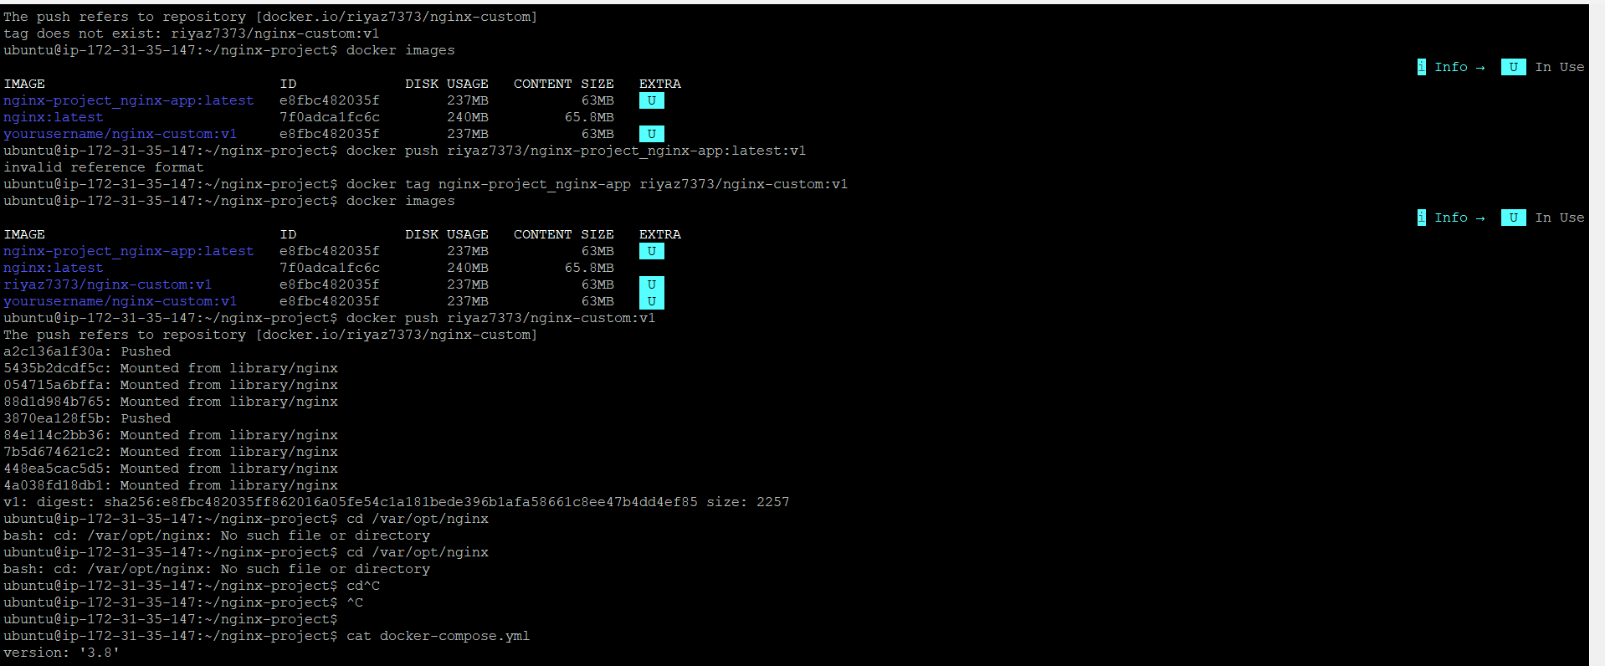
Docker hub Dashboard:
